PALLAM PAVAN KUMAR

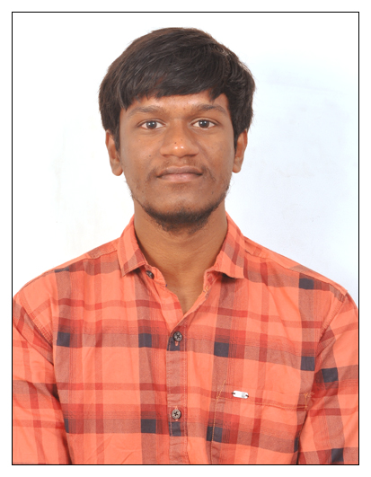

# Certifications:

# Java By coding ninjas

* Spring by udemy
* Spring boot by udemy

# Skills

* Java
* Hibernate
* Spring
* Spring boot
* microservices

# Education:

* Degree: Bachelor of Engineering

# Trainings:

# Java Fsd angular by wipro

# Java Backend development

# By Global EDX

# Frontend Backend development

# (Angular) By Global EDX

# MySql database By Global

# EDX

# Projects:

* **My Time Away - Full Stack Leave Management System:**

Developed a comprehensive leave management system to streamline employee leave processes within an organization. Implemented the backend using Spring Boot with a MySQL database, and the frontend using Angular. Key features included adding, updating, deleting, and searching leave requests, as well as functionalities for cancelling, approving, and rejecting leave requests.

* **Quiz Application By Using Spring boot and Microservices**

Created a Backend quiz application by using spring boot and microservices. Understood how a REST API application works.